**Mediaspace/Kaltura Guide**

Kaltura Mediaspace is a video-centric site that enables both professors and students alike to share, collaborate, and engage with one another through the use of video. This guide will provide a brief overview of the basics of Kaltura Mediaspace, covering things such as uploading videos, adding captions, and editing.

**Uploading Videos**

To upload a video or audio file to your MediaSpace account from a computer:

*Log into* MediaSpace at [https://mediaspace.minnstate.edu](https://mediaspace.minnstate.edu/) with your **StarID username and password**. This will take you to your My Media page.

*Select* *Media Upload from the Add New menu  
*Other options include recording from Webcam and Kaltura Capture.  


***Choose* a file** to upload or Drag & Drop a File.  
Once you have selected your file, a copy of it will begin to upload. At the top of the Upload Media window you will see a progress bar.

Once the file upload is complete, you can change the title, add a description, add keywords or tags, and select file access permissions

***Select* Save** to complete the process.

To return to your videos***select***the My Media page*.*  
When you upload media to your MediaSpace account, you will need to select one of three file sharing permission settings. This setting can be changed later, so pick the setting that best applies at the moment:

* **Private:** Only you will be able to access the file. If you are adding the videos to D2L with the “Insert Stuff” or “Exisiting Activities” method, you can still use this Private setting.
* **Unlisted:** Only those with a link to the file that you provide will be able to access it. Select this option if you want to share your video using a direct link to the video that you might share via email.
* **Published:** Assign the file to a MediaSpace channel. Note: this option could make your video publicly available to all Minnstate.

*************************************************************************************

**Uploading to Mediaspace Through Mobile Devices**

Record your video with your Android or iPhone Camera application.

In your phone’s web browser, navigate to [**https://mediaspace.minnstate.edu**](https://mediaspace.minnstate.edu/) and log in with your StarID. Warning: uploading video can use a lot of data. We recommend that you only upload video when you have a wired connection.

*Click* the **+** in the top right hand corner of the window and *select* **Media Upload**from the drop down menu.

**[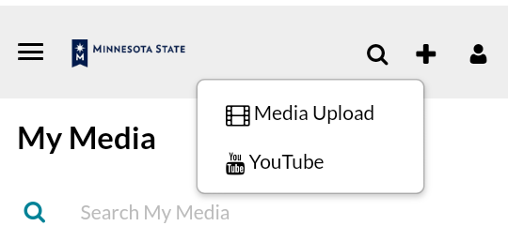](https://www.bemidjistate.edu/offices/its/wp-content/uploads/sites/60/2017/12/addphone.png)**

*Click* on the **Choose a file to upload** button and select the video you want to upload.

**[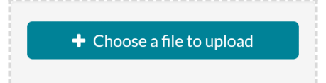](https://www.bemidjistate.edu/offices/its/wp-content/uploads/sites/60/2017/12/choosefile.png)**

*iPhones will commonly have videos stored in the phone’s camera role.*  
*Android phones typically store files in the Documents/Gallery.*A progress bar will show when the upload is complete.  
File name, description and tags can be changed.

*Click* **Save** at the bottom of the screen when you are done setting metadata.

*************************************************************************************

**Uploading to D2L**

Embed your MediaSpace video in D2L Brightspace using the Existing Activities button.

*1.Click* the **Existing Activities** button in a course content module.  
*Select* **My Media** (this will show your MediaSpace files)

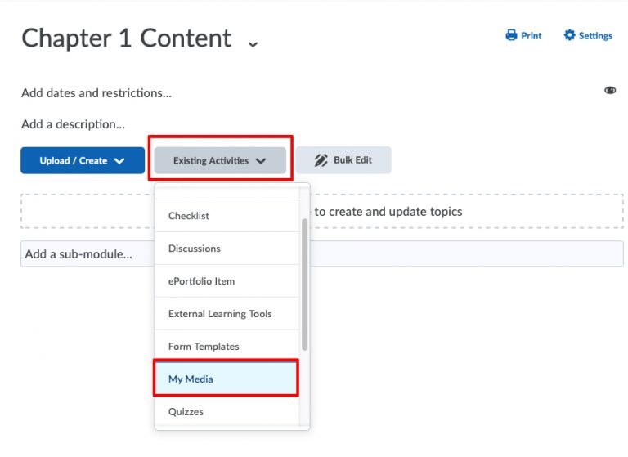

2. *Scroll*to the **video** you want to share. *Click* the **Embed Options**icon.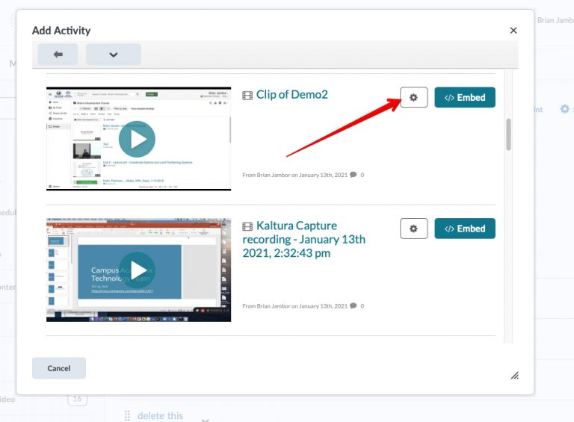3. *Select* the **Video Player size/features**.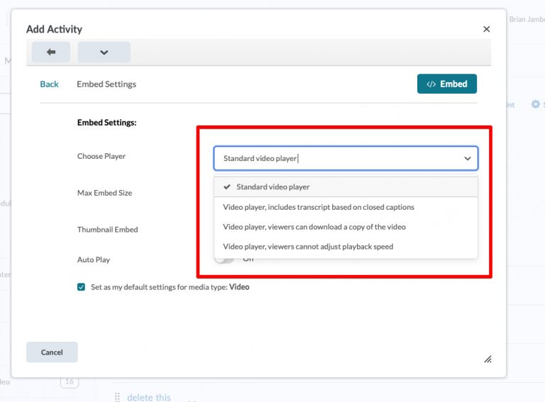

4. *Select* the **Embed Size.** *Click* **Embed**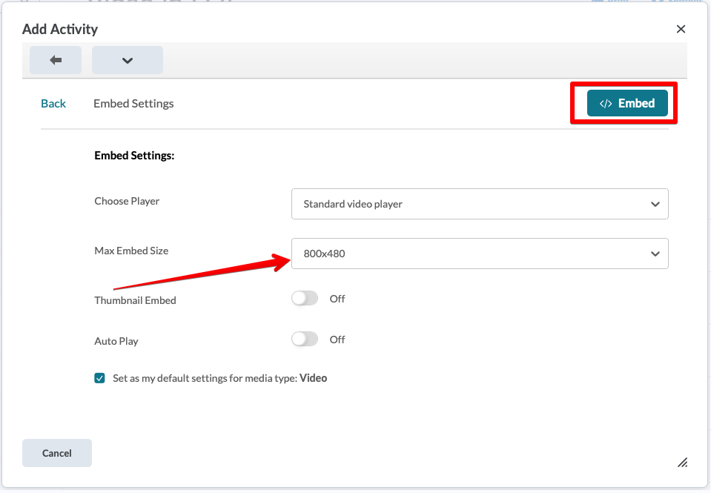

5. Your video link will appear in the content module.

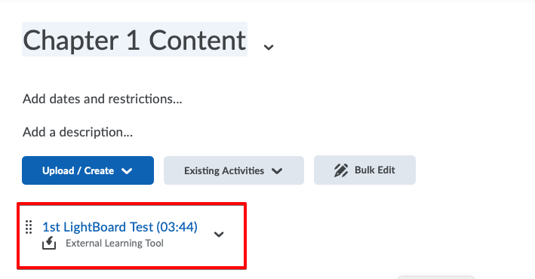

The title and descriptions are editable by *selecting* **Edit Properties In-Place.** *Click* the **Drop Down Arrow** to the right of the link.

*************************************************************************************

**Using Closed Captions**

In the upper-right corner, click ***Actions -> Publish****.*Select the***Published***option, and then open the ***Publish in Channel* tab**. **Check *Order Captions*** and click ***Save*:**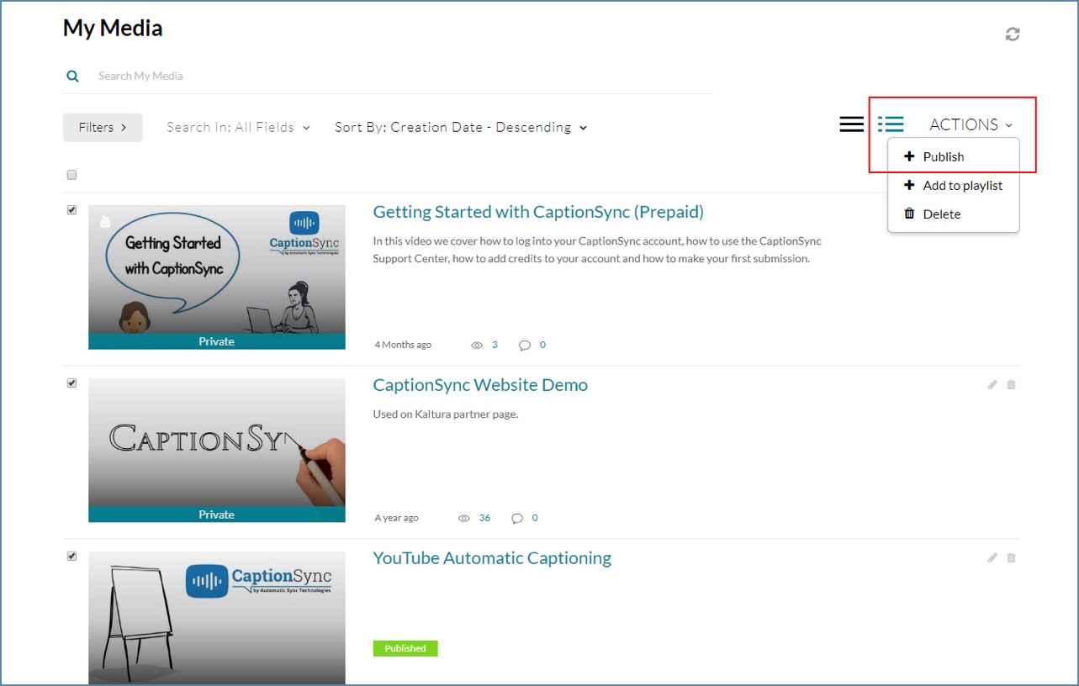

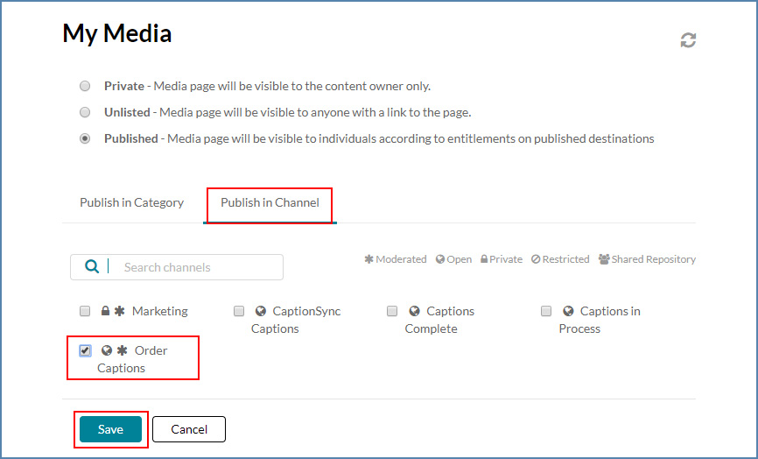

Note that, if moderation is set up in your system, a moderator will need to approve all requests before they are processed for captioning.

Viewing the Status of the Request:

To view the status, details of a request, [cancel it](https://support.automaticsync.com/hc/en-us/articles/202355355-Canceling-a-Transcription-Request) or to submit a redo, log into CaptionSync and go to ***Captioning -> Status of Submissions***. You may also use the Kaltura ID to track the status of your submissions by pasting the ID at the end of https://web.automaticsync.com/show_details.php?ka_id= URL; then copy and paste the URL in your browser.

Once captions are associated with a video, you can turn captions on/off during playback by clicking the *CC* button in the player toolbar.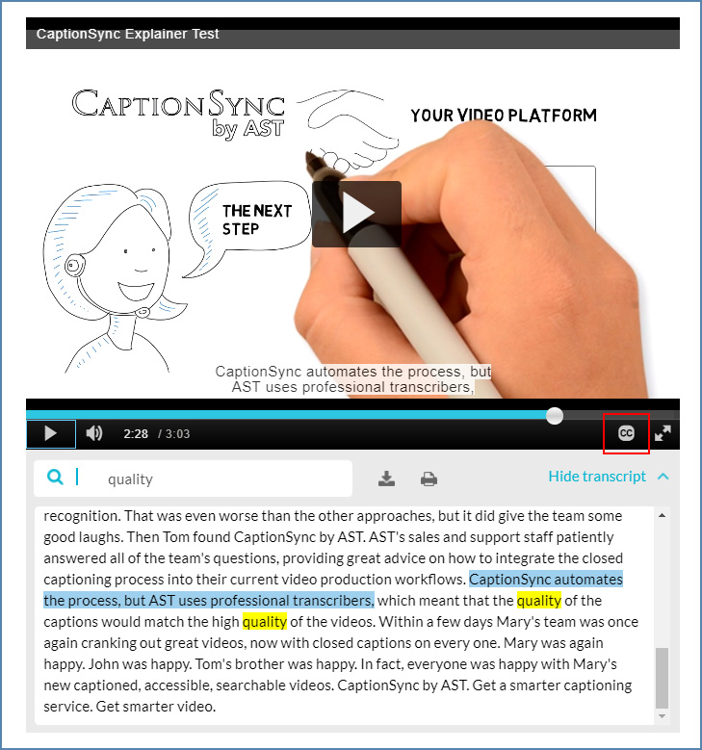

*************************************************************************************

Kaltura Capture

Kaltura Capture has a simple user interface, requiring only one click to record, without a complex setup or a lengthy learning curve. Kaltura Capture is supported on both Windows and Mac. You can record two camera inputs at once, two screens, or a camera and a screen. Kaltura Capture automatically uploads new videos into the Kaltura MediaSpace video portal or Kaltura integrations with Learning and Content Management Systems.

Kaltura Capture includes:

* Screen, webcam, and audio capture in one click
* Automatic slide detection and creation of searchable chapters
* Support for software management install
* Seamless uploading to Learning and Content Management Systems and Kaltura MediaSpace
* Intuitive user interface

**Recording Camera and Screen**

Camera and settings are set to the optimal quality available by default, so you can start recording. If you would like to change the camera or screen input or other settings perform the following steps:To set your camera and screen settings

1. Click on the arrow next to the Video icon.  
   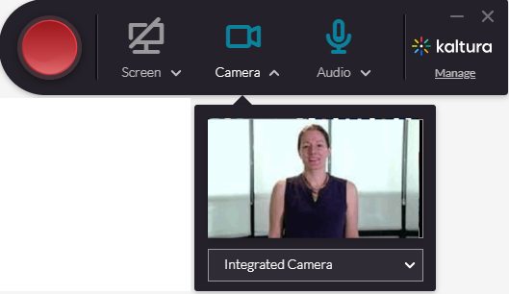
2. Select the Input source (camera) you are going to record from, from the drop-down menu.  If there is more than one camera connected to your PC, select the camera you want to record from.
3. Click on the arrow next to screen icon.
4. Select the screen you are going to record from the Screen drop-down menu. If there is more than one screen connected to your PC, select the screen you would like to record.
5. Click Full Screen to record the entire screen. Click Select Area to record a set area of your screen. Choose the relevant area or customize the screen area by resizing the cropping window.

The next step is saving or uploading your recording.

*************************************************************************************

**Recording Your Camera**

Camera settings are set to the optimal quality available by default, so you can start recording. If you would like to change the camera input or other camera settings perform the following steps:

To set your Camera input

1. Click on the arrow next to the Video icon.  
   
2. Select the Input source (camera) you are going to record from, from the drop-down menu.
3. If there is more than one camera connected to your PC, select the camera you want to record from.
4. Click on the second input to turn it off and record the camera only.

*************************************************************************************

**Recording Two Cameras**

To set your inputs for two cameras

1. Click on the arrow next to each input icon (camera or screen).  
   
2. Select the Input source (camera) you are going to record from, from the drop-down menu.

*************************************************************************************

**Recording Your Screen or Partial Screen**

The input (screen or camera) drop-down menu contains a list of connected devices. Click on a different screen to change it.

Screen settings are set to the optimal quality available by default, so you can start recording. You can record your entire screen (full screen) or a portion of your screen.

To set your screen inputs

1. Click on the arrow next to the input icon (camera or screen).  
   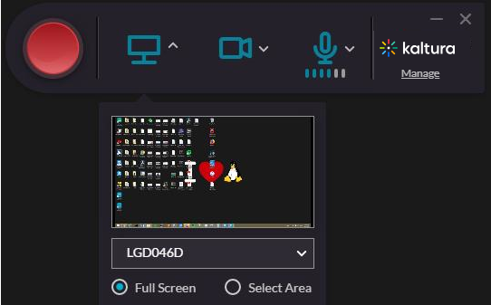
2. Select the screen you are going to record from, from the drop-down menu.
3. If there is more than one screen connected to your PC, select the screen you want to record from.
4. Click Full Screen to record the entire screen. Click Select Area to record a set area of your screen display.  
   The cropping screen is displayed.  
   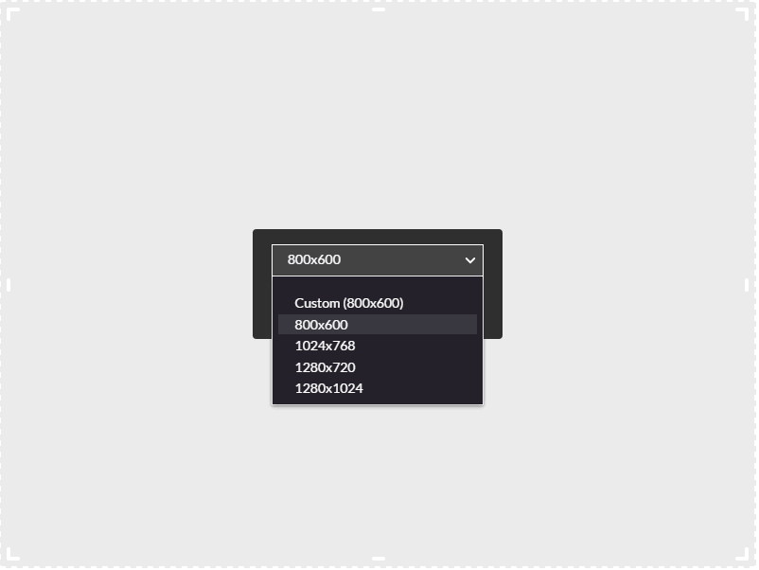
5. Select an area from one of the options. The default area is 800x600 pixels. You can also customize the screen area you want to record by resizing the cropping window. Drag the frame to the size you want to record.
6. Place the resized frame over the screen that you want to record. Click Confirm and the frame turns red. Begin your recording. If you decide to cancel, toggle Full Screen under the screen selection.
7. Click on the second input to turn it off if you want to record screen only.

*************************************************************************************

**Recording a Presentation**

When you record a slide presentation the Kaltura Capture application uploads the slides as chapters and indexes the text so it can be searched for in the video. When recording slides, PowerPoint must be in Slide Show mode. PowerPoint Viewer is not supported for Kaltura Capture recordings.

To set your screen settings for recording a presentation

1. Click on the arrow next to the screen icon.
2. Select the screen you are going to record from, from the drop-down menu.
3. Start recording and change the slides.

After you save and upload your recording, the presentation is displayed on your KMS instance with each slide representing a chapter. You can search for text through the content.

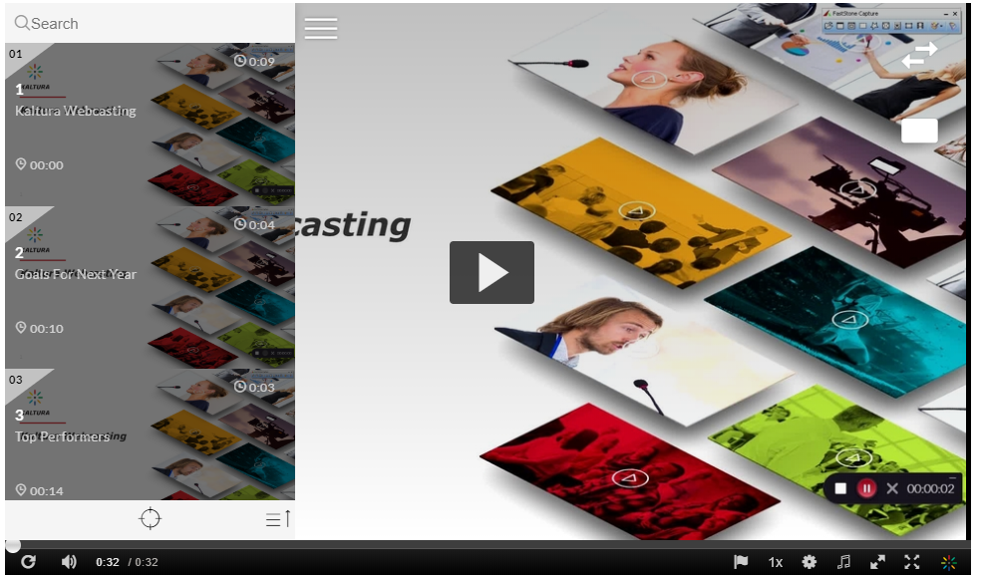

*************************************************************************************

**Recording Two Screens**

To set your inputs to two screens

1. Click on the arrow next to the inputs icon
2. Open the input drop down menu and select the second screen from the list.  
   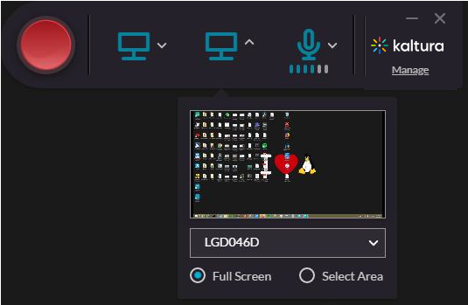
3. Select Full screen or Select Area to record a select are of your screen. See[here](https://knowledge.kaltura.com/help/kaltura-capture-recording-options#partial) for a description of these options.

*************************************************************************************

**Recording Audio Only**

To set the Audio input

1. Disable both input icons that appear on the Recorder by clicking on them.
2. Click on the arrow next to the Microphone icon.
3. Select the audio source you are going to record from, from the drop-down menu.  If there is more than one microphone connected to your PC, select the microphone you want to record from the drop-down menu.

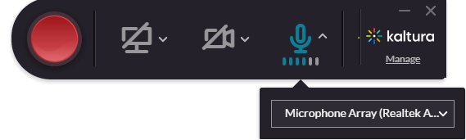

**Completing and Uploading Your Recording**

Completing Your Recording

After you "stop" your recording you will be directed to the entry page. If you clicked stop by mistake, you can always click Cancel and you will be returned to your recording in a paused state. If you want to complete the recording, enter the following information and click save:

* Title of the recording
* Description
* Tags  
  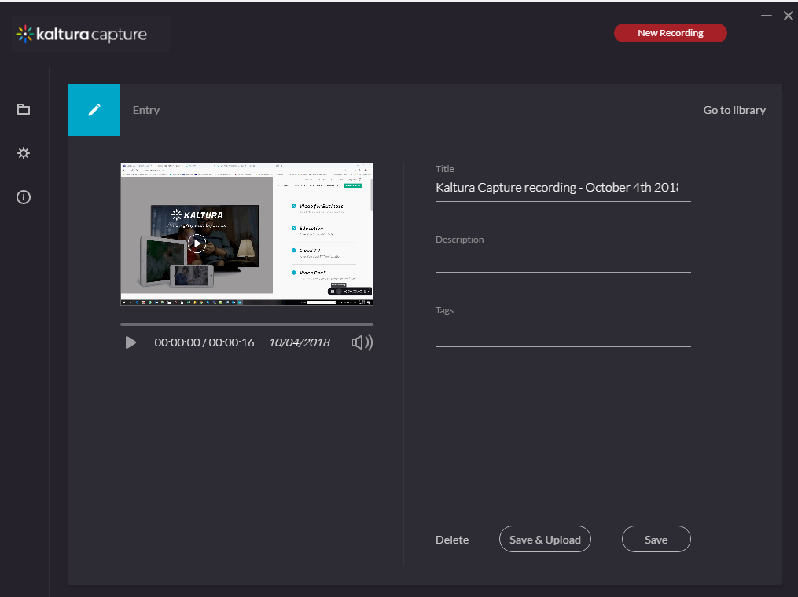

Select one of the following options:

* Delete to delete your entry.
* Save and Upload to upload to Kaltura MediaSpace or your KAF application.
* Save to save to your local Library only. You will be able to Upload at a later time from your media library.
* Start a new recording - you will be prompted with a confirmation that you indeed want to leave.
* Playback your recording.

When you Save a recording without uploading it, the Management window opens with the Edit tab and displays the options to Upload or Detete your media. You can also select Delete all uploaded to delete all uploaded media files from your local storage.  
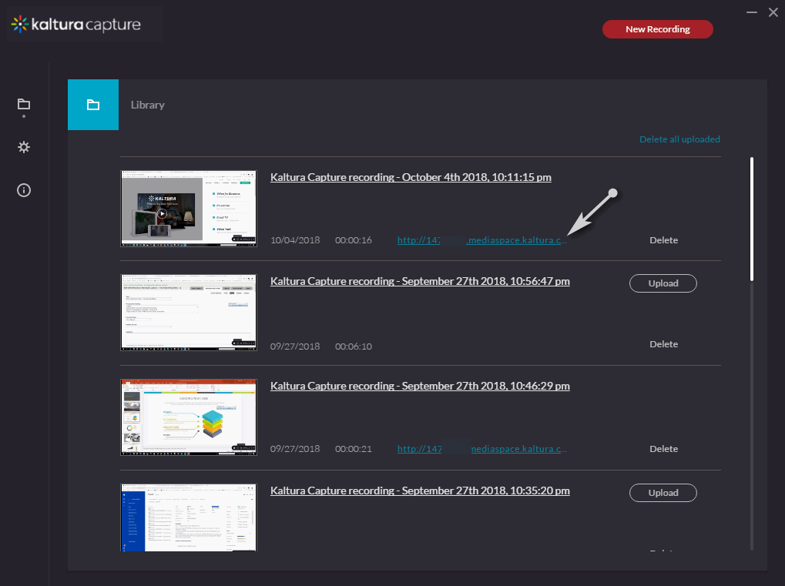

Click Upload. A pending status is displayed and a successful upload message appears when the upload is completed.

Saving and Uploading Your Recording

After you “Stop” recording, the following message is displayed.  
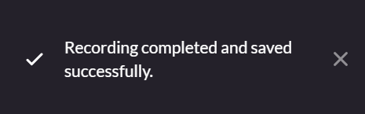

The process of uploading your recording to MediaSpace or a KAF application is seamless.

The following message is displayed:

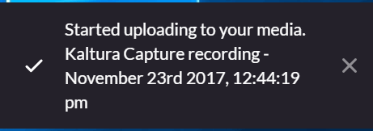

The final message that your recording was saved successfully is displayed.

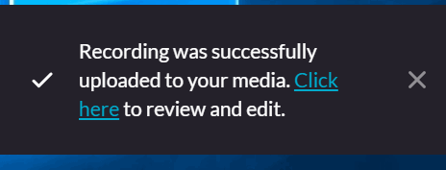

All the recorded videos are stored locally in your Recordings directory. If you have not changed the Recordings directory during the installation, the default recording directory is C:ProgramFiles/KalturaCapture/Recordings.

Your recording is automatically uploaded to your Kaltura account (to the user specified in the “User ID” field in the Recording Details screen).

Upload is done in the background regardless of the user that is logged in. After you save your recording, you can start a new one or log off and the recording will continue to upload.

When you Click Here in the successful upload screen, you are automatically directed to your Kaltura Mediaspace or KAF instance.

Closing Kaltura Capture While There is an Upload Running in the Background

You may close the application in the midst of an upload. The following warning message will be displayed:

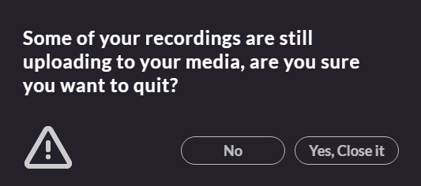

Select No to close the confirmation popup. Select Yes to quit and close the confirmation popup, exit the application, and stop the upload.

Viewing the Kaltura Capture Recording in MediaSpace and in KAF Applications

To view the Kaltura Capture Recording

1. Click on the link that is displayed next to your media in the Management Window.  
   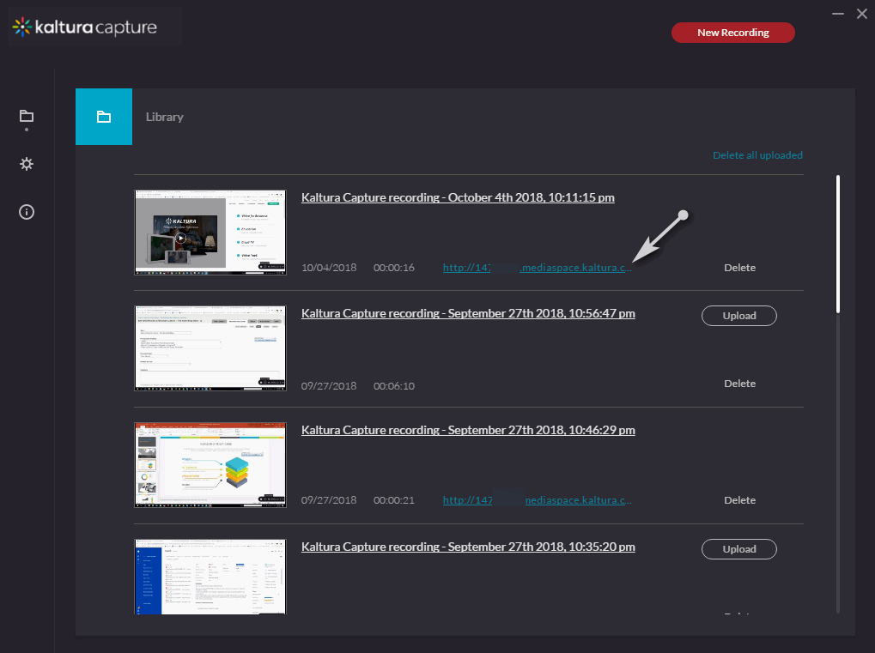  
   or go to your MediaSpace or KAF instance and select My Media.  
   The Kaltura Personal Capture recorded media thumbnail is displayed.  
   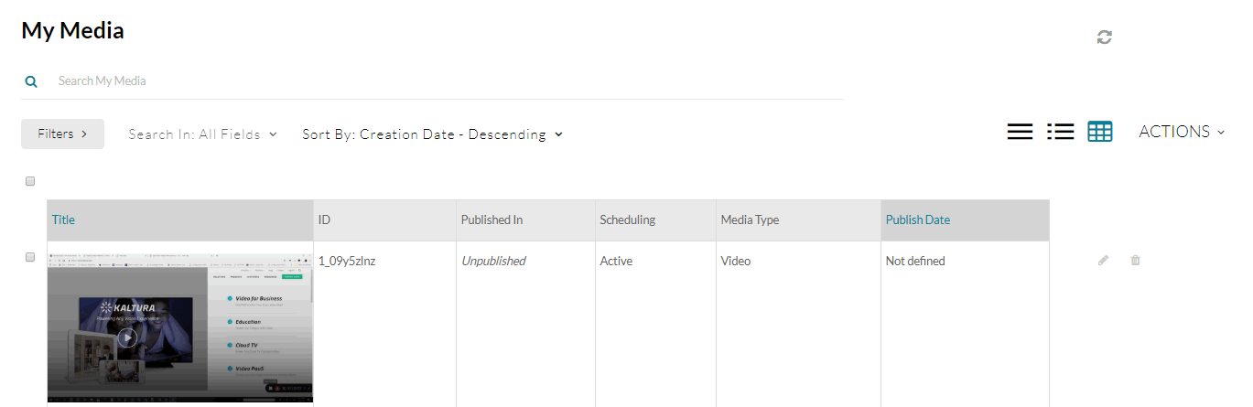
2. Click on the media and then press Play.
3. Use the Kaltura Player’s rich media viewing options to take full advantage of the multiple interactive viewing options for your recording.

Editing Your Video Using Kaltura

1. Log into Kaltura MediaSpace,
   * 1. Select a course to find the **My Media** tab.
2. From the **My Media** page find your video and click the **edit** icon Canvas kaltura Edit icon, located to the right of the video.
3. Select the **Launch Editor** button. *The video editor opens.*
4. A timeline of your video displays at the bottom of the editor. The vertical teal line shows where you are in the video and shows three options for editing your content.  
   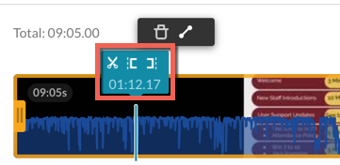
   * **Set In** (represented by an opening bracket icon) allows you to set a start time for your video.
     1. You can trim unwanted recorded material, such as an audio check at the start of a lecture recording.
   * **Set Out** (represented by a closing bracket icon) allows you to set an end time for your video.
     1. You can trim recording that happens after a presentation, such as an audience leaving.
   * **Split** (represented by a scissors icon) allows you to create different video sections to edit and modify.
     1. Using **Split** enables the **Fade In/Out**option.
     2. Splitting content allows you to delete chunks of content within your video.
   * Above the timeline are the options to **Delete** or **Fade In/Out**.
     1. **Delete** (represented by a garbage can icon) allows you to:
        1. Hover over a section
        2. Select the section
        3. Delete the section from the video
     2. **Fade In/Out** (represented by a line icon with circles on the ends) allows you to set a transition for a clip to fade in or out.
        1. Hover over a section
        2. Select the desired amount of seconds you'd like the clip to fade in or out.  
           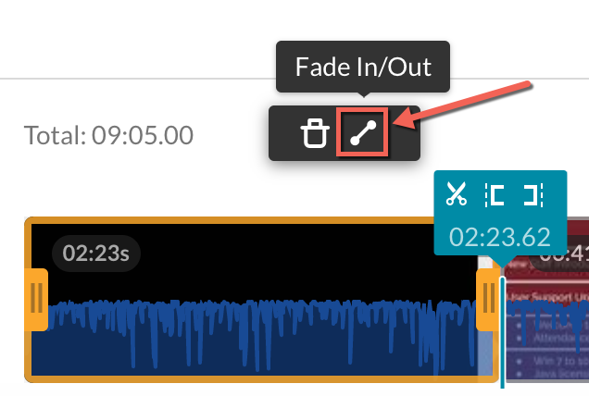
5. An audio waveform displays in blue, within the video timeline. This lets you visually identify high and low points in the audio. If you need to remove the audio for editing:
   * Directly below the video is the **Select Audio** button. Select it and choose to**Hide Audio**.  
     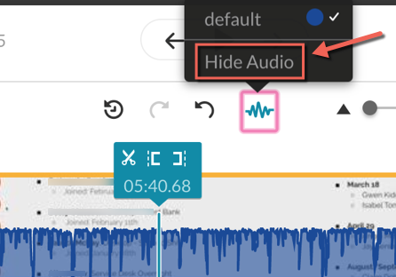
   * If at any time you need the audio overlay back, choose **Select Audio** again and click **Show Audio**.
6. When you are done editing your video, select the appropriate save option:
   * **Save a Copy** (preferred): Creates a new file with your edited video while also retaining the original video. This option:
     1. takes less time to save
     2. automatically trims existing captions
     3. results in a new clip, which means the previous video you shared with viewers will stay the same
   * **Save:**Selecting this option in the upper right saves the newly edited video, overwriting the original.